Advancing Cancer Equity (ACE) Fund

Guidelines

December 2025

Summary
Funding Objective: The ACE Fund provides crucial early support for scalable projects that improve the safety, accessibility, and effectiveness of cancer care for underserved communities.
Project Funding: $60,000 (excluding GST) per project, with two projects to be funded.
Duration: Projects are expected to commence in July 2026 for a maximum period of up to 18 months. Duration may vary depending on the contractual agreement.
Expression of Interest Process: All proposals should be completed using the Expression of Interest template at the end of this document and submitted on time. Proposals will be evaluated by the Selection Panel including representatives of the VCCC Alliance’s Health Equity Advisory Group.
Due Date: EOIs open on 1 February 2026 and are due by 27 February 2026.
**This EOI is only open to members and associate members of the VCCC Alliance.

Contact and submission details
Dr Lesley McKarney, Senior Manager Health Equity, VCCC Alliance
E: lesley.mckarney@vcccalliance.org.au
M: 0481 173 207

Key Dates
Milestone | Dates
- EOI opens | 1 February 2026
- EOI closes | 27 February 2026
- Review, ranking and shortlisting of applications | 2 to 13 March 2026
- Shortlisted applicants notified and invited to a brief interview | 16 to 27 March 2026
- All applicants notified of outcome | 3 April 2026
- Project(s) commencement | From 1 July 2026

Background
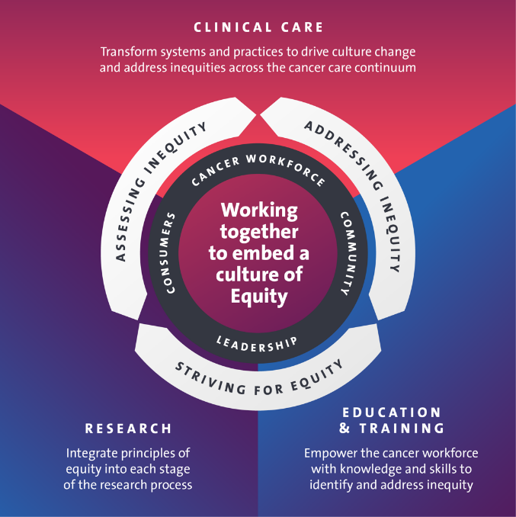
The Health Equity Program is a key initiative within the Strategic Programs division of the VCCC Alliance. A fundamental goal of this program is to build capacity and capability across the VCCC Alliance and beyond to improve equity in cancer treatment, experience and outcomes across Victoria. Our work directly supports two major strategic plans: the Victorian Cancer Plan 2024-2028 and the VCCC Alliance 2024-2029 Strategic Plan.
The VCCC Alliance has developed a Cancer Equity Framework which guides our program, the broader VCCC Alliance, and the cancer sector. This framework supports a continuous cycle of action designed to embed a culture of equity, where leaders, healthcare professionals, consumers and communities collaborate to address the root causes of inequity (see image).

Guided by the Cancer Equity Framework, the VCCC Alliance’s Health Equity Program is focused on four key areas:

- Regional collaboration to address local needs
- Inclusive research and service design to ensure care is accessible to all
- Improving cancer related health outcomes for Aboriginal and Torres Strait Islander Peoples, and
- Data-driven improvement to measure our impact and guide our efforts.

Advancing Cancer Equity Fund
The Advancing Cancer Equity (ACE) Fund is designed to support smaller-scale, proof-of-concept projects that often face significant barriers to traditional funding. These projects are designed to lay the groundwork for larger health equity research efforts, ultimately driving a cultural shift across the cancer care sector. Our goal is to select projects that are not only innovative and scalable, but also directly aligned with the Health Equity Program’s overall objective of increasing the cultural safety, accessibility and effectiveness of cancer care services for:

- Aboriginal and Torres Strait Islander Peoples
- People from Culturally and Linguistically Diverse (CALD) backgrounds, and
- Regional & rural communities.

The ACE Fund supports, celebrates and showcases individual health equity initiatives in cancer to create a critical mass of positive change. This includes proposals that address challenges in equitable access to screening, diagnosis and treatment of cancer, cultural safety and inclusive clinical research, including but not limited to issues raised and discussed as part of the Cancer Equity Framework.

Further, there is a particular focus on proposals that do one or more of the following:

- Identify one or more of the priority groups who are the focus of the research (eligible list provided in the application)
- Contribute to the existing research and practice knowledge base on equity issues in cancer care and control
- Produce research that can be applied, adopted, or scaled up by health services across Victoria
- Employ innovative use of existing data sources or identify and use new data sources in program design and evaluation
- Take a comparative and/or interdisciplinary approach to understand equity issues
- Foster collaboration through two or more members and/or associate members of the VCCC Alliance.

Selection Process

Oversight
Reducing the evidenced disparities in cancer outcomes requires an intersectional approach and carefully targeted and strategic action. The Health Equity Advisory Group, established in 2025, provides high-level expertise to the Health Equity Program and to VCCC Alliance members and associate members on the development and implementation of strategies to maximise the contribution of the alliance to addressing inequities in cancer outcomes across Victoria. The Health Equity Advisory Group will provide oversight of the successful ACE projects.

Eligibility
This funding is only available to staff from VCCC Alliance member and associate member organisations. Partnerships with communities, NGOs and ACCOs are encouraged.
Funding for two research projects is available through a competitive selection process. Grants will be funded for up to $60,000 (excluding GST) per project.

Page limit
The completed EOI should be 4 to 6 pages in total, exclusive of CVs. CV to accompany application should be 2-page maximum, with current and prior positions and/or experience (last 5 years), and a 100-word statement of impact of the applicant’s track record of research with priority communities. Relevant publications may be included.

Timetable for Selection and Awarding
The ACE Fund selection process involves two stages:
- Initial Expression of Interest (EOI) (4 to 6 pages) submitted
- Following EOI review, 2 to 3 shortlisted applicants will be invited to a short interview.

Review process
The EOI and Full Application evaluation panel will consist of:
- Co-Chairs, Health Equity Advisory Group, VCCC Alliance
- Consumer Member, Health Equity Advisory Group, VCCC Alliance
- Senior Manager Health Equity, VCCC Alliance
- Senior Manager Research, VCCC Alliance

The EOIs and Full Applications will be reviewed using the following process:
- Completeness of application
- Ranking and shortlisting against criteria (below)

Criteria for assessment
- Impact, Significance, and Sustainability (40%)
The project must demonstrate clear community need.
- Priority Need: Project addresses an area of need identified and prioritised by the affected community (Aboriginal and Torres Strait Islander Peoples, CALD communities, or regional/rural people affected by cancer).
- Foundation: Clearly describes the existing practice/project the proposal builds upon or ideally, pilots a new idea based on an evidence-based unmet need.
- Innovation & Future Contribution: Is innovative (design or implementation) and identifies how it will contribute to the field beyond the project timeline.
- Alignment, Collaboration, and Support (40%)
The project must align with the VCCC Alliance mission and involve a skilled, collaborative team.
- VCCC Alignment: Aligns with Health Equity Program deliverables and Cancer Equity Framework principles.
- Collaboration: Includes a minimum of two VCCC Alliance organisations. Collaboration with community organisations or groups is encouraged.
- Team Expertise: The team's composition must be multi-disciplinary, demonstrating a mix of research and practice skills.
- Team Clarity: The skills, experience, time allocation and contribution of all team members must be clearly identified.
- Institutional Support: Confirmation of host organisation support.
- Project Budget and Duration (20%)
The proposal must feature a realistic budget and adhere to the timeline constraints.
- Budget Clarity: Budget is clear and realistic.
- Permissible Expenses: Funding is used for permissible purposes (e.g., short-term project personnel, project expenses). Excludes recruitment costs, institutional infrastructure or overhead charges.
- Duration: Total project duration is no longer than 18 months from the award date.

NOTE: EOI applications can be made from 1st February to 27th February 2026, by downloading the form on our website. Earlier applications will not be accepted.

