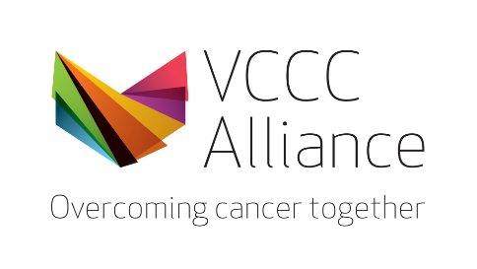

Time | Item | Topic | Speaker
1.00-1.05pm | Welcome | Welcome and Acknowledgement of Country  Opening remarks - the importance of mRNA technologies for the cancer sector | Prof Grant McArthur  Executive Director, VCCC Alliance
1.05-1.20pm | Keynote 1 | Advancements across the mRNA vaccine and therapeutic development pipeline, including new data from their personalised cancer vaccine trials for melanoma and future plans for cancer | Dr Paul Burton  Chief Medical Officer, Moderna Therapeutics
1.20-1.35pm | Keynote 2 | Clinical implications for mRNA technologies in cancer vaccines and therapeutics | Prof Sherene Loi  Head of Translational Breast Cancer Genomics and Therapeutics Laboratory, Peter MacCallum Cancer Centre
1.35-2.00pm | Panel discussion | The technology and its potential  Clinical perspective  Immunological perspective  Importance of mRNA technologies for the Victorian Health Sector  Consumer perspective | Dr Paul Burton  Prof Sherene Loi  Prof Laura Mackay, Laboratory Head and Immunology Theme Leader, The Doherty Institute  Dr Amanda Caples, Victoria’s Lead Scientist and Director Breakthrough Victoria  Dr Karin Innes, Melanoma Research Victoria Consumer Reference Group and Governance Committee
a paradigm shift
Advancing mRNA from COVID to cancer

Seminar program

Wednesday 3 May 1.00pm–2.00pm

