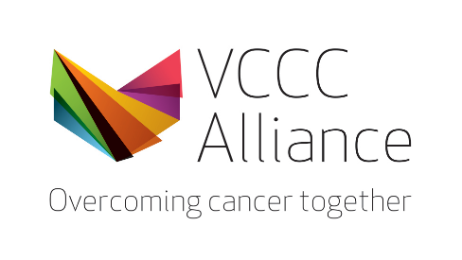
Melbourne MicroCerts (MMCs) – Emerging Topics in Oncology Series

Clinical Trial Protocol Design

Scholarship Application Form

This form is to be used by VCCC Alliance Members or members of the regional cancer workforce who would like to apply for a 75% fee remission award to support enrolment in the Emerging Topics in Oncology Series Melbourne MircroCerts (MMC) – Clinical Trial Protocol Design.

Scholarship type (please select one) | Registry Trials (preference will be given to those from non-haematology and non-medical oncology disciplines)  OR  Clinical Trials Development Hub (preference will be given to those considering early phase)
Title and name of applicant
Health Care, Medical Research Institute or Educational organisation
(eg: St Vincent’s Hospital)
Department
(eg. Dept. of Palliative Care)
Current role
(eg. Head of Haematology, NUM)
An introduction of yourself
What is your current involvement in cancer research, education, or clinical care?
What contribution would this make to your professional development and future career?

Limited to 500 words

Please attach your curriculum vitae to this form and email Clinical Trials Development Hub and early phase trials scholarship applications to elizabeth.diao@unimelb.edu.au and Registry Trials scholarships applications to eleonora.kay@unimelb.edu.au

