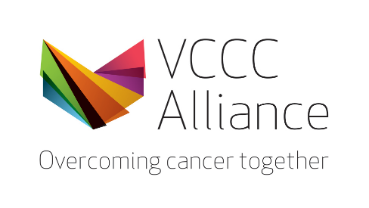
Melbourne MicroCerts (MMCs) – Emerging Topics in Oncology Series
Scholarship award

Application Form

This form is to be used by VCCC Alliance staff from member organisations or members of the regional cancer workforce who would like to apply for a 50% fee remission award to support enrolment in the Using Genomic Data for Personalised Care Melbourne MicroCerts (MMC).

Title
Given Name
Family Name
Email
Health Care, Medical Research Institute or Educational organisation
(eg: St Vincent’s Hospital)
Department
(eg. Dept. of Palliative Care)
Current role
(eg. Head of Haematology, NUM)
Personal biography (short description)
What is your current involvement in cancer research, education, or clinical care?
What/how many years of professional experience do you have in genomics?
Why do you want to attend this course?
How will participation in this course contribute to your professional growth in your organisation and the broader VCCC Alliance?

Limited to 500 words

Please attach your curriculum vitae to this form.

