Standard Operating Procedure:

Handling and Shipping of Infectious Substances with Teletrials

SOP Number: TT-SOP-09

SOP Number: | TT-SOP-09
Version Number: | 2.0
Effective date: | 13 September 2019
Review date: | 13 September 2022
Author(s): | Hannah Cross  VCCC Program Manager
Approved by: | VCCC Teletrials Steering Committee

This is a controlled document. It should not be altered in any way without the expressed permission of the developer and the approver.

Amendment History
Version | Date | Amended By | Amendment Details
1.0 | 03 October 2018 | Hannah Cross | New
2.0 | 13 September 2019 | Alana Donaldson | Additional information regarding electronic documentation on Site Docs Portal.  Additional information regarding training requirements.

Developed by the Victorian Comprehensive Cancer Centre (VCCC) in conjunction with the Parkville Cancer Clinical Trials Unit (PCCTU), based on the Clinical Oncology Society of Australia (COSA) Australasian Tele-trials Model.

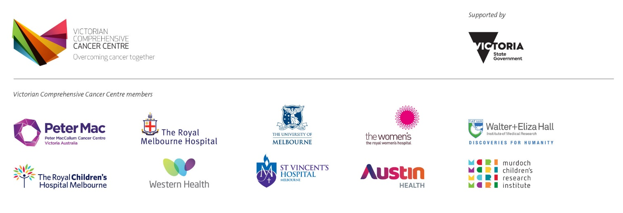
viccompcancerctr.org

- Introduction and Background
Handling and shipping clinical trial participant central samples is often required in order to assess eligibility, safety parameters, measure response to treatment and to assess pharmacokinetics, pharmacodynamics and pharmacogenomics (central samples). Central samples form a crucial part of clinical trial analysis and is the primary end point to most clinical trial protocols.
Correct handling and shipping procedures are vital in ensuring the integrity of the sample.
- Objective
To describe the procedure for the handling and shipping of infectious substances in clinical trials.
- Scope
This SOP applies to all members of the study team involved in the handling and shipping of central samples, including all the satellite site study team.
- Ownership and Responsibility
The principal investigator is responsible for ensuring study team members are appropriately trained and delegated to handle and ship central samples as outlined in (SITE) TT-SOP-03 Clinical Trial Training and (SITE) TT-SOP-04 Delegation of Duties (see Related Documents).
The study team members delegated to handle and ship samples (SITE team member or (SITE) laboratory staff) are required to complete International Air Transport Association (IATA) shipping and handling training, renewed every three years as well as initial protocol training and protocol amendments training relevant to delegated duties. Documented laboratory manual training will be completed by (SITE) laboratory staff only.
- Glossary of Terms
Please refer to (SITE) TT-SOP-Glossary-of-Terms (see Related Documents) for full supporting glossary of terms.
- Procedure
- Handling Potential Infectious Substances
The delegated (SITE) study team member or (SITE) laboratory staff have oversight of clinical trial specific central sample requirements and utilise unit templates (i.e. SITE Trial Sample Log, see Related Documents) to ensure appropriate handling of all protocol mandated samples at specified time points and document the storage and shipping of samples where appropriate to enable adequate tracking. (SITE) laboratory staff are responsible for the coordination of equipment maintenance in accordance with Preventive Maintenance-Medical Devices Policy (SITE).
Central samples are handled in accordance with the clinical trial specific laboratory manual and stored centrally for easy reference.
Personal Protective Equipment (PPE) is utilised while handling all central samples as outlined in (SITE) Clinical Procedures (see Related Documents).
- Shipping Potentially Infectious Substances
The (SITE) study team and/or laboratory staff will:
- Complete checks of shipping materials, including waybill, shipping invoice and customs declaration if applicable, to ensure all required components are available and consistent with the laboratory manual requirements.
- Ensure samples are packaged according to the instructions outlined in the laboratory manual.
- Provide appropriate completed shipping documents with provision for Identification checks on collection and couriers booked for pick up from Clinical Trials Laboratory.
- Tracking Potentially Infectious Substances
The (SITE) study team and/or laboratory staff will:
- Ensure adequate documentation of handling and shipping is maintained and copies of the shipping documents retained for tracking purposes. This includes the completion of the (SITE) Trial Sample Log
- Dissemination and Implementation
Approved SOPs will be disseminated electronically by (SITE). SOPs will be made available in hard copy format or electronically through Site Docs Portal. Any updates to the existing approved SOPs will be disseminated internally, and will be effective immediately.
- Monitoring Compliance and Effectiveness
Compliance with this SOP will be monitored as part of the (SITE) monitoring and audit process. Any queries concerning the effectiveness of this SOP identified during the (SITE) monitoring process or through use will be addressed and may result in the requirement to update the SOP.
- Review and Updating
This SOP will be reviewed every three years, or when changes to legislation or working practices that impact upon the content of this document. This SOP may be merged with another SOP if appropriate or removed entirely if it becomes redundant.
- Reference(s)
(SITE) Preventative Maintenance-Medical Devices.
- Related Document(s)
(SITE) TT-SOP-03: Clinical Trial Training
(SITE) TT-SOP-04: Delegation of Duties
(SITE) Trial Sample Log
(SITE) Centre Policy on Preventive Maintenance.
(SITE) Clinical Procedure Personal Protective Equipment

