Standard Operating Procedure:

Management of Investigational Product

SOP Number: TT-SOP-13

SOP Number: | TT-SOP-13
Version Number: | 1.0
Effective date: | XX September 2019
Review date: | XX September 2022
Author(s): | Alana Donaldson  VCCC Program Manager
Approved by: | VCCC Teletrials Steering Committee

This is a controlled document. It should not be altered in any way without the expressed permission of the developer and the approver.

Amendment History
Version | Date | Amended By | Amendment Details

Developed by the Victorian Comprehensive Cancer Centre (VCCC) in conjunction with the Parkville Cancer Clinical Trials Unit (PCCTU), based on the Clinical Oncology Society of Australia (COSA) Australasian Tele-trials Model.

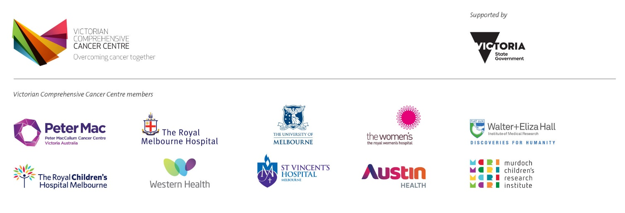
viccompcancerctr.org

- Introduction and Background
Good clinical practice requires investigational product accountability at the trial site. It also requires that the investigational product(s) are used only in accordance with the approved study protocol.
Correct management of investigational product is vital to ensure that the product is accounted for and stored and distributed correctly for clinical trials.
- Objective
To describe the procedure for the management of all aspects of Investigational Product, either medicinal product or device. Management includes but is not limited to the receipt, storage, accountability, preparation and administration, shipment and destruction of investigational product.
NB: relabelling of investigational product is not covered here as will follow the institutions pharmacy procedures for relabelling.
- Scope
This SOP applies to all members of the study team involved in the handling and shipping of investigational product, including all the satellite site study team. All study personnel involved in the clinical study must operate within their scope of practice.
- Ownership and Responsibility
The principal investigator is responsible for ensuring study team members are appropriately trained and delegated to the management of investigational product as outlined in (SITE) TT-SOP-03 Clinical Trial Training and (SITE) TT-SOP-04 Delegation of Duties (see Related Documents).
The study team members delegated to the management of investigational product (SITE team member or pharmacy staff) are required to complete TransCelerate recognised ICH-GCP training and any additional pharmacy training as required.
- Glossary of Terms
Please refer to (SITE) TT-SOP-Glossary-of-Terms (see Related Documents) for full supporting glossary of terms.
- Procedure
- Management of Investigational Product (Medicinal Product or Device)
The responsibility for investigational product(s) accountability at the trial site(s) rests with the investigator, however an investigator may delegate responsibility for IP management to the site pharmacist. The investigator, pharmacist or appropriately qualified non-pharmacist must ensure:
- the investigational product is used only in accordance with the approved protocol
- the investigational product is received, stored, prepared, administered, shipped and destroyed as specified by the sponsor in accordance with the Protocol, pharmacy manual and applicable regulatory requirements. Consideration must be given to security of the investigational product with restricted access to approved personnel.
- Prescribing
All prescriptions for the use of investigational products for clinical studies are completed in accordance with standard hospital prescription procedures and the study protocol.
- Receipt and storage of investigational product
Ensure that the investigational product is received from the sponsor and stored respecting correct temperature control and provide maintenance and calibration records for storage equipment (e.g. refrigerators, thermometers) in accordance with sponsor requirements.
Ensure that any deviation to required temperature, storage conditions, potential defect/issue with investigational product is notified to sponsor in a timely manner and in accordance with the study protocol, following study site quarantine processes where applicable.
- Transportation of investigational product to a satellite site
Where the investigational product needs to be transported to, or returned from, a satellite destination, the appropriate transfer method, respecting temperature control, is to be used according to the protocol and sponsor’s guidelines. Correct documentation to accompany the shipment and filed accordingly.
Investigational product will be shipped by courier using an approved shipping device as determined by the protocol and/or instruction from the pharmacist. The shippers will be able to accommodate both refrigerated and ambient (2-8°C + 15-25°C) temperatures and maintain the temperatures for 48 hours in the Australian climate via the use of temperature loggers.
The satellite pharmacy who is receiving the investigational product will follow the process for investigational product management as outlined in the site-specific Supervision Plan.
- Maintain records
The investigator, pharmacist or appropriately qualified non-pharmacist must maintain records of all aspects of the management of the investigational product. These records as a minimum should include dates, quantities, batch/serial numbers, expiration dates (if applicable), and the unique code numbers assigned to the investigational product and to the trial participant.
- Provide counselling on use of investigational product
The investigator, pharmacist or delegated study team member must explain the correct use of the investigational product to each participant and should check, at intervals appropriate for the trial, that each participant is following the instructions properly. Instruct participant where relevant to return empty and partially used medication containers at their next visit. Extra counseling by the investigator or delegate, for study participants regarding poor medication compliance may be required.
When a participant is collecting medication from a satellite site under the teletrial model, the satellite pharmacy will follow the process for investigational product management as outlined in the site-specific Supervision Plan.
- Randomisation and unblinding of investigational product
The investigator, pharmacist or delegated study team member must ffollow the trial's randomisation procedures, if any, and ensure that the code is broken only in accordance with the protocol. If the trial is blinded, the investigator must promptly document and explain to the sponsor any premature unblinding (e.g., accidental unblinding, unblinding due to a serious adverse event) of the investigational product.
- Manufacture of investigational product
Where an investigational product requires manufacture, the site pharmacist or suitably qualified delegate with a thorough understanding of, and training in, the application of Good Manufacturing Practice (GCP) to investigational products as specified in the protocol. Co-operation is required with trial sponsors who undertake the ultimate responsibility for all aspects of the clinical trial including the quality of investigational products.
NB: the above manufacturing requirements do not apply to reconstitution of an investigational product.
- Returns, reconciliation and destruction of investigational product
All product containers, including the unused product, packs and other packaging for the investigational product are retained by the participants and returned to the site pharmacy on cessation or exit from the study for accounting and return to the sponsor or destruction as per sponsor requirements:
- The return of investigational product (used and unused packets) are recorded within the Case Report Form
- Once accounted for, all unused/partially used/expired returns will either be returned to the sponsor or be destroyed at the site pharmacy following pharmacy procedures in accordance with the protocol and sponsor requirements
- If not able to be destroyed at the time of receipt, investigational product must be clearly identified and quarantined in a secure location of the site pharmacy to be destroyed at a later time
- Destruction of unused investigational product should be carried out for a given trial site or a given trial period only after any discrepancies have been investigated and satisfactorily explained and the reconciliation has been accepted. Recording of destruction operations should be carried out in such a manner that all operations may be accounted for
- Recalls of investigational product
Procedures for retrieving investigational products and documenting this retrieval should be agreed by the sponsor, in collaboration with the manufacturer or importer where different. The investigator and monitor need to understand their obligations under the retrieval procedure.
The sponsor should ensure that the supplier of any comparator or other medication to be used in a clinical trial has a system for communicating to the sponsor the need to recall any product supplied.
- Dissemination and Implementation
Approved SOPs will be disseminated electronically by (SITE). SOPs will be made available in hard copy format or electronically upon request. Any updates to the existing approved SOPs will be disseminated internally, and will be effective immediately.
- Monitoring Compliance and Effectiveness
Compliance with this SOP will be monitored as part of the (SITE) monitoring and audit process. Any queries concerning the effectiveness of this SOP identified during the (SITE) monitoring process or through use will be addressed and may result in the requirement to update the SOP.
- Review and Updating
This SOP will be reviewed every three years, or when changes to legislation or working practices that impact upon the content of this document. This SOP may be merged with another SOP if appropriate or removed entirely if it becomes redundant.
- Reference(s)
VMIA Standard Operating Procedures to achieve Good Clinical Practice (GCP) in Australian clinical research, VMIA (2007)
Guide to Good Manufacturing Practice for Medicinal Products - Annexe 13: Manufacture of Investigational Medicinal Products, TGA (2017)
- Related Document(s)
(SITE) TT-SOP-03: Clinical Trial Training
(SITE) TT-SOP-04: Delegation of Duties
(SITE) Trial Sample Log
(SITE) Centre Policy on Preventive Maintenance.
(SITE) Clinical Procedure Personal Protective Equipment

- Appendices
Appendix 1. Example of IP Accountability Record

Appendix 1. Example of Investigational Product Accountability Record