Standard Operating Procedure:

Management of External Safety Information with Teletrials

SOP Number: TT-SOP-07

SOP Number: | TT-SOP-07
Version Number: | 1.0
Effective date: | 03 October 2018
Review date: | 03 October 2021
Author(s): | Hannah Cross  VCCC Program Manager
Approved by: | VCCC Teletrials Steering Committee

This is a controlled document. It should not be altered in any way without the expressed permission of the developer and the approver.

Amendment History
Version | Date | Amended By | Amendment Details

Developed by the Victorian Comprehensive Cancer Centre (VCCC) in conjunction with the Parkville Cancer Clinical Trials Unit (PCCTU), based on the Clinical Oncology Society of Australia (COSA) Australasian Tele-trials Model.

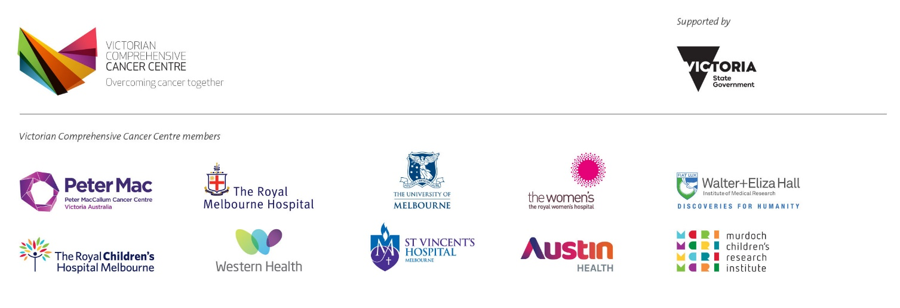
viccompcancerctr.org

Introduction and Background
International Conference on Harmonisation Good Clinical Practice (ICH GCP) guidelines defines the requirements to ensure that all clinical trial participants taking part in a clinical trial are safe and their rights protected. In the event that a safety concern is raised in a clinical trial specific procedures should be adhered to as per National Health and Medical Research Council (NHMRC) and local Human Research Ethics Committee (HREC) reporting requirements. (International Conference on Harmonisation of Technical Requirements for Registration of Pharmaceuticals for Human Use, 1996).
- Objective
To describe the procedure related to the management of all external safety information.
- Scope
This SOP applies to all clinical trials coordinated by (SITE), including all Teletrials.
- Ownership and Responsibility
The sponsor/contract research organisation (CRO), investigator/other designee(s) are responsible for ensuring the safety oversight of the clinical trial.
The sponsor/CRO conducting the clinical trial is responsible to comply with the NHMRC safety monitoring and reporting in clinical trials involving therapeutic goods guidance (2016).
The sponsor/CRO is responsible for reporting any new safety information to the principal investigator that may pose a risk to clinical trial participants.
- Glossary of Terms
Please refer to (SITE) TT-SOP-Glossary-of-Terms for full supporting glossary of terms.
- Procedure
(SITE) endorses the NHMRC safety monitoring and reporting in clinical trials involving therapeutic goods guidance (2016). The sponsor/CRO is expected to:
- “Sponsors should evaluate all safety information that is reported by investigators as well as safety information from other sources.” (NHMRC, 2016, sec. 1)
- “provide the HREC with an annual safety report including a clear summary of the evolving safety profile of the trial. This report should allow the HRECs to assess whether ongoing safety monitoring is being conducted appropriately and that the trial’s safety monitoring plans are being followed and where necessary, are being adapted to take into account new findings as the trial progresses.” (NHMRC, 2016, sec.1.g)
- Annual Safety Report
The annual safety report should generally include:
- a brief description and analysis of new and relevant findings
- for IMPs not on the Australian Register of Therapeutic Goods, a brief analysis of the safety profile of the IMP and its implications for participants taking into account all available safety data and the results of relevant clinical or non-clinical studies
- a brief discussion of the implications of the safety data to the trial’s risk-benefit ratio
- a description of any measures taken or proposed to minimise risks.” (NHMRC, 2016, sec. 1.g)
- Development Safety Update Report (DSUR)
A DSUR may be submitted as the annual safety report. Submission will take place between the HREC and the sponsor/CRO. The (SITE) team coordinating the clinical trials team should be copied into the emails containing the annual reports and the reports will be filed in the investigator site files or electronically. HREC acknowledgment of the annual report will be filed in the investigator site files (ISF) or electronically.
“Sponsors can discharge this responsibility by placing these reports on a portal or by sending them via e-mail.” (NHMRC, 2016, sec.1 note 1) As such (SITE) nominates to receive safety related documents via email as an acceptable method rather than access individual sponsor/CRO portals.
- Dear Investigator Letters (DIL)
DIL impacting the management of the clinical trial or clinical trial participant safety will be actioned as follows:
- If the principal investigator deems a DIL requiring immediate action, clinical trial participants will be contacted immediately.
- If the principal investigator determines no immediate action is required, clinical trial participant will be notified of the update at their next visit.
- DIL will be submitted to HREC as a noting item.
- Line Listings
Single line listings or 6 monthly line listings received by site will be filed in investigator site file if received in hard copy format or filed electronically if received by email: requiring no other action from the study team.
- Training
Training on updated safety information will not be undertaken or documented as outlined in (SITE) TT-SOP-03: Clinical Trial Training with Teletrials (see Related Documents).
- Dissemination and Implementation
Approved SOPs will be disseminated electronically by (SITE). SOPs will be made available in hard copy format or electronically upon request. Any updates to the existing approved SOPs will be disseminated internally, and will be effective immediately.
- Monitoring Compliance and Effectiveness
Compliance with this SOP will be monitored as part of the (SITE) monitoring and audit process. Any queries concerning the effectiveness of this SOP identified during the (SITE) monitoring process or through use will be addressed and may result in the requirement to update the SOP.
- Review and Updating
This SOP will be reviewed every three years, or when changes to legislation or working practices that impact upon the content of this document. This SOP may be merged with another SOP if appropriate or removed entirely if it becomes redundant.
- Reference(s)
International Conference on Harmonisation of Technical Requirements for Registration of Pharmaceuticals for Human Use. (1996). Guideline for Good Clinical Practice E6(R1).
National Health and Medical Research Council. (2016). Guidance: Safety monitoring and reporting in clinical trials involving therapeutic goods.
- Related Document(s)
(SITE) TT-SOP-Glossary-of-Terms
(SITE) TT-SOP-03: Clinical Trial Training

