Standard Operating Procedure:

Clinical Trial Training with Teletrials

SOP Number: TT-SOP-03

SOP Number: | TT-SOP-03
Version Number: | 2.0
Effective date: | 13 September 2019
Review date: | 13 September 2022
Author(s): | Hannah Cross  VCCC Program Manager
Approved by: | VCCC Teletrials Steering Committee

This is a controlled document. It should not be altered in any way without the expressed permission of the developer and the approver.

Amendment History
Version | Date | Amended By | Amendment Details
1.0 | 03 October 2018 | Hannah Cross | New
2.0 | 13 September 2019 | Alana Donaldson | Additional wording clarifying the process of amendment training on training documents.  Clarification of amendment protocol training being completed prior to ethical and governance approval.  Amendment protocol training by electronic training method through Site Docs Portal added.  Update requirement of all staff delegated to handle and ship samples to complete laboratory manual training.

Developed by the Victorian Comprehensive Cancer Centre (VCCC) in conjunction with the Parkville Cancer Clinical Trials Unit (PCCTU), based on the Clinical Oncology Society of Australia (COSA) Australasian Tele-trials Model.

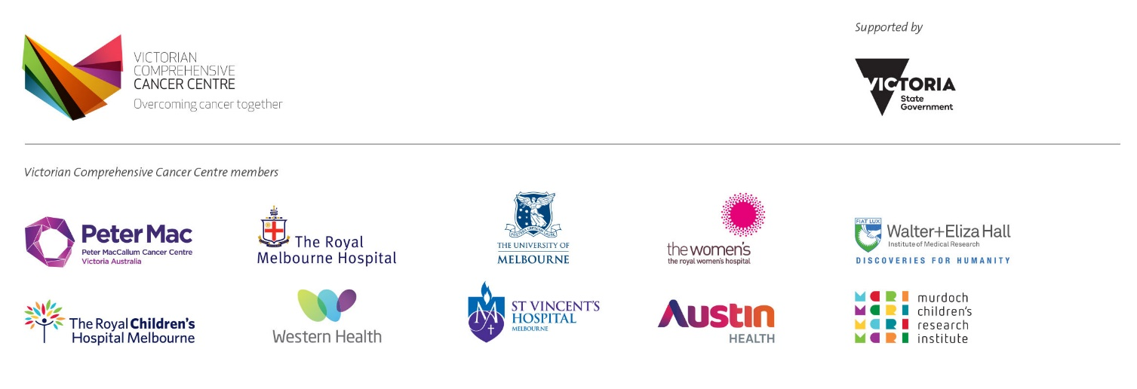
viccompcancerctr.org

- Introduction and Background
As mandated by the International Conference on Harmonisation Good Clinical Practice (ICH GCP) all study team members performing clinical trial related tasks are required to be qualified to do so by education, training and experience. Study team members must be adequately delegated and supported in order to perform their duties. The principal investigator is responsible for the supervision of all study team members and retains overall responsibility for the conduct, delegation and training on protocol and clinical trial related requirements.
- Objective
To describe the procedure for documenting training that has been undertaken by members of the study team.
- Scope
This SOP applies to the principal investigator and to all members of the study team.
This SOP applies to all Teletrials undertaken at (SITE).
- Ownership and Responsibility
The principal investigator is responsible to ensure all study team members have the necessary expertise and experience in order to successfully perform the task(s) delegated to them.
- Glossary of Terms
Please refer to (Site) -SOP-Glossary of Terms (see Related Documents) for full supporting glossary of terms.
- Procedure
- Initial Protocol Training
Prior to performing any clinical trial related tasks, initial training will be performed either by the principal investigator or delegate as appropriate to the delegated role (self-directed learning tool or sponsor/clinical research organisation trainer). By definition, initial training includes protocol and patient informed consent form (PICF) training and is documented as one by current protocol version.
Training is documented on the (SITE) Training Log (see Related Documents). Once appropriately trained, duties will then be delegated by the principal investigator as outlined in (Site)-SOP-04: Delegation of Duties (see Related Documents) and documented on the (SITE) Delegation of Duties Log (see Related Documents).
Study team members are not required to document training in sponsor mandated portals.
- Protocol Amendment Training
- The principal investigator is responsible for identifying required training on amendments to the protocol in a timely manner. In order to facilitate training once ethical and governance approval is obtained, training documents will be available prior to approval.
- The principal investigator or delegate will provide the study team with training materials (i.e. training slides, summary of changes or tracked changes of approved amendment) via email or electronic training through Site Docs Portal. Upon receipt, study team members will be required to reply to confirm they have read and understood the changes.
- The principal investigator will complete a training memorandum to document the relevant training and date of training for all study team members based on their email acknowledgement. The principal investigator is responsible to countersign all protocol amendment training.
- Electronic protocol amendment training can be performed through Site Docs Portal. Once an updated protocol is uploaded to the electronic investigator site file (eISF) the study team is automatically sent an email reminder to read and understand. Outstanding actions items appear on the home page under ‘Action Dashboard’ until completed. Training is tracked within the document view by user, status and time signed and cannot be manually updated.
- Protocol amendments including a PICF amendment will be documented by protocol version only.
- Investigator Brochure (IB) Training
- The IB is a reference document which informs the protocol and safety section of the PICF.
- Updated versions of the IB are acknowledged by the principal investigator and documented on IB signature page (if provided by sponsor) or electronically through Site Docs Portal. Once an updated IB is uploaded to the eISF the principal investigator is automatically sent an email reminder to acknowledge as received. Outstanding actions items appear on the home page under ‘Action Dashboard’ until completed. Acknowledgement is tracked within the document view by user, status and time signed and cannot be manually updated.
- Training will be performed on protocol or PICF amendment as a result of IB update.
- Urgent Safety Data Training
  - The Sponsor is responsible for the dissemination of urgent safety data (including Dear Investigator letters requiring immediate action) to the principal investigator and SITE team coordinating the clinical trial via email.
  - The principal investigator will disseminate urgent safety data to the study team, per SITE-TT-SOP-07: Management of External Safety information (see Related Documents).
- Training will be performed on protocol or PICF amendment updated as a result of urgent safety information.
- Other Training Requirements
Study team members are required to complete internal training on relevant (SITE) SOPs and work practice guidelines and policies. Internal training records can be viewed on prior request.
All study team members are required to have valid TransCelerate ICH GCP training.
Delegated study team members are required to complete training on the following supplementary trial documents:
- Study team members delegated to process samples per (SITE) Delegation of Duties Log (see related documents) will complete laboratory sample processing on the laboratory manual.
- (SITE) laboratory staff will undertake relevant training as outlined in (SITE) TT-SOP-09: Handling and Shipping of Infectious Substances (see Related Documents)
- Study team members delegated to make entries/corrections on (e)CRF and Sign off (e)CRFs per (SITE) Delegation of Duties Log (see Related Documents) will complete electronic case report form (eCRF) training modules and provide relevant certificates through Site Docs Portal or paper investigator site file as required.

Only relevant study members are required to undergo or document training in supplementary trial documents such as:
- Investigator Brochure.
- SAE reporting including Dear Investigator letters and aggregated reports.
- Lab manuals or updates.
- Electronic case report form (eCRF) guideline or updates.
- Patient informed consent form (PICF).

- Staff Indirectly Involved in Trial Conduct
Staff within the precinct (listed below, but not limited to) who as part of their routine practice complete a procedure (i.e. vital signs, electrocardiography ECG, venepuncture or imaging) on a patient who may also be participating in a clinical trial will not be considered part of the study team. As such they are not required to undertake clinical trial education, training and delegation.
- Clinicians,
- Specialist nurses,
- Nurses,
- Laboratory staff,
- Ophthalmologists,
- Radiologists,
- Pathologists and
- Technicians.
The principal investigator is responsible for the oversight and interpretation of the results provided from the above mentioned staff and the actions required.
- Departmental Responsibilities
Departments within the precinct may have clinical trial related duties (i.e. intravenous investigational product administration) assigned to them by the principal investigator. A named person will assume responsibility for the conduct of such activity for that department and as such will be delegated this task on the delegation of duties log. The named person will be required to undertake appropriate protocol training relevant to the undertake activity.
- Dissemination and Implementation
Approved SOPs will be disseminated electronically by (SITE). SOPs will be made available in hard copy format or electronically upon request. Any updates to the existing approved SOPs will be disseminated internally, and will be effective immediately.
- Monitoring Compliance and Effectiveness
Compliance with this SOP will be monitored as part of the (SITE) monitoring and audit process. Any queries concerning the effectiveness of this SOP identified during the (SITE) monitoring process or through use will be addressed and may result in the requirement to update the SOP.
- Review and Updating
This SOP will be reviewed every three years, or when changes to legislation or working practices that impact upon the content of this document. This SOP may be merged with another SOP if appropriate or removed entirely if it becomes redundant.
- Reference(s)
International Conference on Harmonisation of Technical Requirements for Registration of Pharmaceuticals for Human Use. (1996). Guideline for Good Clinical Practice E6(R1).
Integrated addendum to ICH E6(R1): Guideline for Good Clinical Practice E6(R2)
- Related Documents
(SITE)-TT- SOP-Glossary-of-Terms
(SITE)-TT- SOP-04: Delegation of Duties
(SITE) Training Log
(SITE) Delegation of Duties Log
(SITE) TT-SOP-09: Handling and Shipping of Infectious Substances

