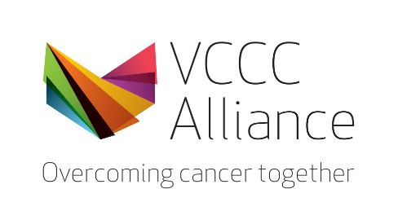
VCCC Alliance Research Conference
Scholarship

Application Form (Workforce)

The Centre for Cancer Education will be offering scholarships to attend the upcoming 2023 VCCC Alliance Research Conference on 12 – 13th September 2023 for staff from VCCC Alliance member organisations, and the regions. The scholarships are for students, postdoctoral researchers, allied health professionals, and nurses. Please note that consumer advocates have a separate application form. Applications close 28 August.

Please select application type:

- Comprehensive Cancer PhD student or other student
- Post Doctoral researcher
- Allied Health professional
- Nurse
- Regional

Title and name of applicant
Health Care, Medical Research Institute or Educational organisation
(eg: St Vincent’s Hospital)
Department
(eg. Dept. of Palliative Care)
Current role
(eg. Head of Haematology, NUM)
An introduction of yourself
What is your current involvement in cancer research, education, or clinical care?
Limited to 250 words
What contribution would this make to your professional development and future career?

Limited to 250 words

