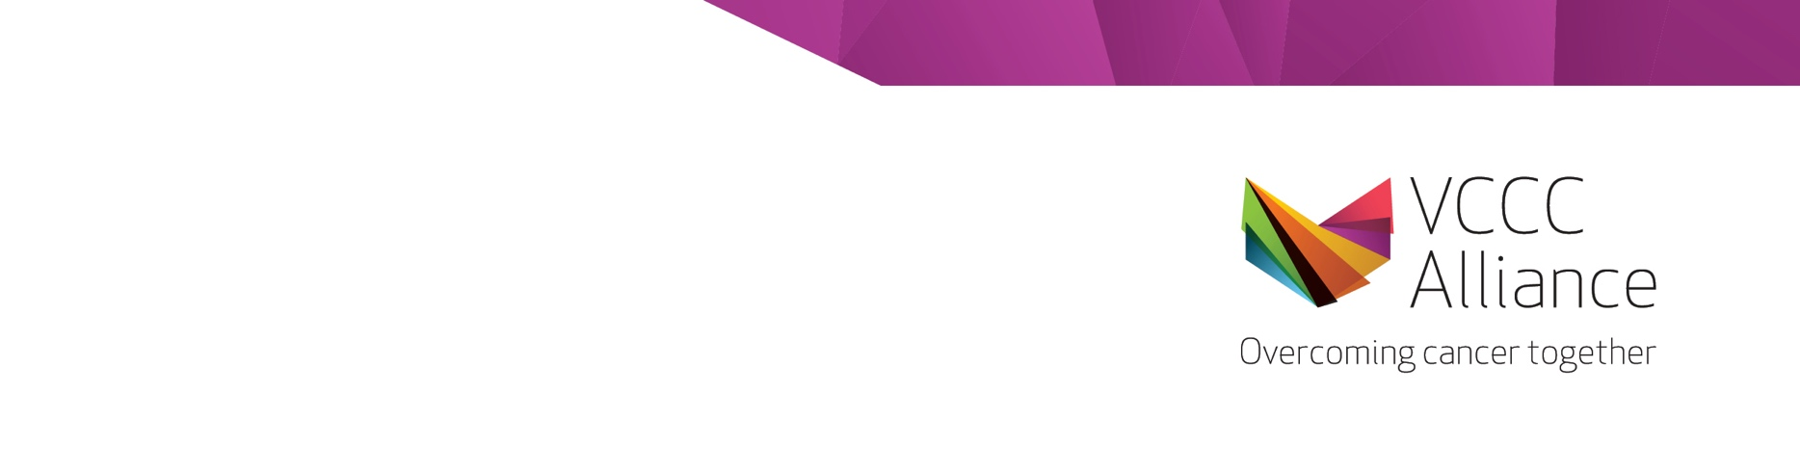

World Indigenous Cancer Conference 2024 - Creative Brief
Monday 18 March – Wednesday 20 March 2024 | Narrm (Melbourne), Australia

Project name | World Indigenous Cancer Conference 2024
Project overview | The World Indigenous Cancer Conference 2024 (WICC) is the third iteration of a WICC, to be presented in March 2024 and for the first time – hosted by the VCCC Alliance.  The conference is timely and will draw on a groundswell of interest and activity including development of a national Aboriginal and Torres Strait Islander cancer strategy, the Australian Cancer Plan, and the Voice Referendum. At the State level it aligns with the Victorian Aboriginal Cancer Journey strategy and the First People’s Assembly of Victoria.  Our objectives for the conference are:  - To share global knowledge that touches on each element of the conference theme:  - Process- implementation of work  - Progress- policy development/service change  - Power- governance/decision-making capacity/self-determination  - To continue to allow connection, and build the community of researchers/health professionals in driving equitable cancer care outcomes for Indigenous peoples.  Approximately 500 delegates are expected to attend.
Conference target audiences | Cancer workforce professionals interested in driving equitable care and outcomes for Indigenous peoples, especially:  - Indigenous consumers (patient and carer advocates/representatives)  - Aboriginal health workforce  - Cancer researchers and scientists  - Researchers of/on Indigenous health and wellbeing  - Aboriginal Community controlled organisations  - Clinician researchers (all disciplines incl nursing and allied health)  - Cancer clinicians (all disciplines)  - Other professionals working in cancer including educators  - Government including federal and state health departments and cancer agencies  - Cancer sector including collaborators and consumers  - Research-support organisations and foundations, including those who have not yet engaged with Indigenous populations  NB: Attendees usually participate from four countries – Australia, USA, NZ, Canada
Project theme | PROCESS | PROGRESS | POWER
Dates | Monday 18 March – Wednesday 20 March 2024  Narrm (Melbourne), Australia
Design requirements | We require a logo that has a distinct and engaging visual identity to help market the conference and generate international interest.  The logo needs to be suitable for use as part of a visual identity for the conference and applied across a wide range of conference materials including website banners and social media posts and digital screens.
Deliverable | Logo design concepts – between 2 - 4 concepts, with possible alterations pending feedback.  Final design to be provided in digital formats (.ai, .eps, .png and .jpg files)

Expressions of interest
Expressions of interest are invited from Aboriginal and Torres Strait Islander artists and designers:
Please submit:
- a one page cover letter outlining your experience and reasons for interest in the project
- resume or biography
- relevant examples of your work
Submission
For any questions or to submit your quote, contact Alice Allan at alice.allan@unimelb.edu.au.
Deadline
Friday July 14, 2023

Submission
For any questions or to submit your quote, contact Alice Allan at alice.allan@unimelb.edu.au.
Deadline
11.59pm, Friday 14 July

